**MIDTERM TEST**

**(1 tiếng rưỡi)**

# Task 1: Review general knowledge. Please find the correct answer to each question. (3p)

## **Which of the following operators is used to compare with pattern matching data from the database?**

1. LIKE
2. SELECT
3. IN

*Your answer:*

**A**

## **What is SQL execution order?**

## SELECT [TOP] 🡪 FROM 🡪 WHERE 🡪 JOIN 🡪 UNION 🡪 ORDER BY

## FROM 🡪 WHERE 🡪 JOIN 🡪 SELECT 🡪 GROUP BY 🡪 ORDER BY 🡪 LIMIT (TOP N)

## FROM 🡪 JOIN 🡪 WHERE 🡪 GROUP BY 🡪 SELECT 🡪 ORDER BY 🡪 LIMIT (TOP N)

*Your answer:*

**C**

## **Which method can help you to query data from multiple tables?**

1. Subquery
2. JOIN
3. UNION
4. All the above answers

*Your answer:*

**D**

## **Which JOIN query results in the below output table?**

## INNER JOIN

## LEFT JOIN

## RIGHT JOIN

## FULL JOIN

*Your answer:*

**B**

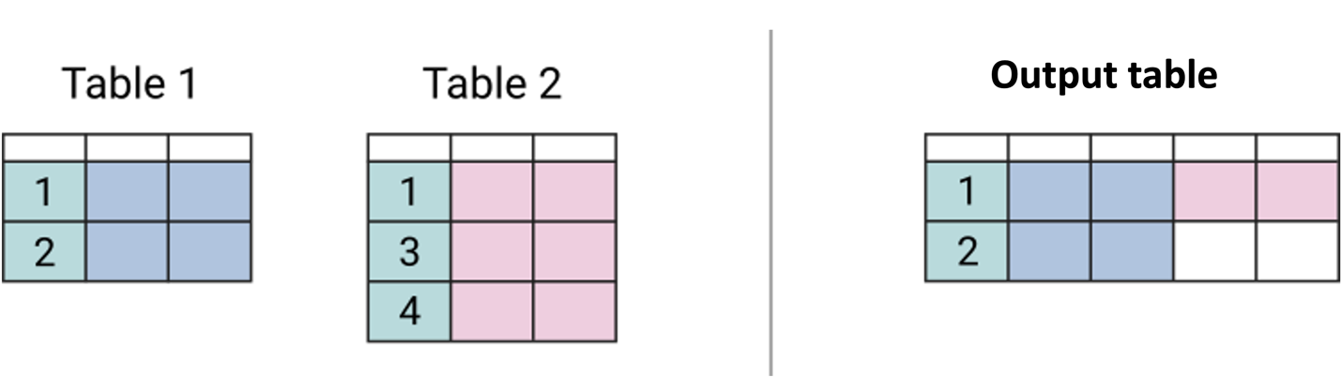

## **1.5. Which JOIN query results in the below output table?**

## INNER JOIN

## LEFT JOIN

## RIGHT JOIN

## FULL JOIN

*Your answer:*

**D**

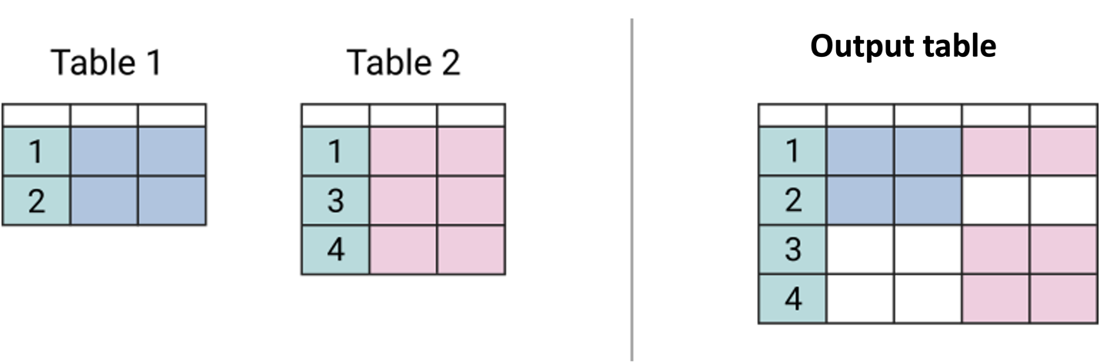

# Task 2: Write queries based on following requirements (3p)

## Retrieve a report that includes the following information*: customer_id, transaction_id, scenario_id, transaction_type, sub_category, category*. These transactions must meet the following conditions: (1.5p)

# Were created in Feb 2019

# Transaction type is not empty (transaction type IS NOT NULL)

-- 2.1. Retrieve a report that includes the following information: customer_id, transaction_id, scenario_id, transaction_type, sub_category, category. These transactions must meet the following conditions: (1.5p)

SELECT customer_id

    , transaction_id

    , fact_19.scenario_id

    , transaction_type

    , sub_category

    , category

FROM fact_transaction_2019 AS fact_19

LEFT JOIN dim_scenario AS scen

ON fact_19.scenario_id = scen.scenario_id

WHERE MONTH(transaction_time) = 2 -- Were created in Feb 2019

AND transaction_type IS NOT NULL -- Transaction type not null

## From payment transaction history in February 2019. **Find the top 10% of failed transactions with the highest transaction value *(charged_amount)***. (1.5p)

*( yêu cầu là tìm ra top 10% giao dịch thất bại của nhóm “Payment” (không thành công) có giá trị charged_amount cao nhất trong tổng số giao dịch payment trong tháng 2/2019)*

-- 2.2. Find the top 10% of failed transactions with the highest transaction value (charged_amount).

WITH joined_table AS(

    SELECT customer_id

    , transaction_id

    , fact_19.scenario_id

    , transaction_type

    , sub_category

    , category

    , charged_amount

FROM fact_transaction_2019 AS fact_19

LEFT JOIN dim_scenario AS scen

ON fact_19.scenario_id = scen.scenario_id

LEFT JOIN dim_status AS stat

ON fact_19.status_id = stat.status_id

WHERE MONTH(transaction_time) = 2 -- Were created in Feb 2019

    AND transaction_type IS NOT NULL -- Transaction type not null

    AND NOT fact_19.status_id = 1

)

SELECT TOP 10 PERCENT *

FROM joined_table

ORDER BY charged_amount DESC

# Task 3: Retrieve an overview report of customer’s payment behaviors

## Paytm has acquired a lot of customers. Retrieve a report that includes the following information: ***the number of transactions, the number of payment scenarios, the number of payment category and the total of charged amount of each customer***. Some additional conditions need to be met: (2p)

* Only show Top 10 highest customers by the total of charged amount
* Transactions created from 01/01/2020 to 31/03/2020
* Status description is successful
* Transaction type is payment

WITH joined_table AS(

    SELECT customer_id

    , count(transaction_id) AS number_trans

    , count(distinct(fact_20.scenario_id)) AS number_scenarios

    , count(distinct(category)) AS number_categories

    , sum(charged_amount) AS total_amount

FROM fact_transaction_2020 AS fact_20

LEFT JOIN dim_scenario AS scen

ON fact_20.scenario_id = scen.scenario_id

WHERE MONTH(transaction_time) < 4

AND status_id = 1

AND transaction_type = 'Payment'

GROUP BY customer_id

)

SELECT TOP 10 *

FROM joined_table

ORDER BY total_amount DESC

## Seeing the customer’s payment behaviors *(from 3.1 with all customers bỏ điều kiện TOP 10, lấy những điều kiện còn lại),* we want to segment customers into 2 groups: (1) whose total amount is greater than the average value of all customers, and (2) whose total is below the average value.

### Find the average of the total amount of all customers, then label who is **“greater_than_avg’**, who is **“lower_than_avg”.** (1p)

WITH joined_table AS(

    SELECT customer_id

    , count(transaction_id) AS number_trans

    , count(distinct(fact_20.scenario_id)) AS number_scenarios

    , count(distinct(category)) AS number_categories

    , CAST(sum(charged_amount) AS FLOAT) AS total_amount

FROM fact_transaction_2020 AS fact_20

LEFT JOIN dim_scenario AS scen

ON fact_20.scenario_id = scen.scenario_id

WHERE MONTH(transaction_time) < 4

AND status_id = 1

AND transaction_type = 'Payment'

GROUP BY customer_id

)

, total_table AS (

SELECT customer_id

    , total_amount

    , (SELECT avg(total_amount) FROM joined_table) AS avg_amount

FROM joined_table

)

SELECT *

    , CASE WHEN total_amount < avg_amount THEN 'lower_than_avg'

    ELSE 'greater_than_avg'

    END group_customers

FROM total_table

### Calculate how many customers **spend more than the average value and how much they account for in total**? (1p)

WITH joined_table AS(

    SELECT customer_id

    , count(transaction_id) AS number_trans

    , count(distinct(fact_20.scenario_id)) AS number_scenarios

    , count(distinct(category)) AS number_categories

    , CAST(sum(charged_amount) AS FLOAT) AS total_amount

FROM fact_transaction_2020 AS fact_20

LEFT JOIN dim_scenario AS scen

ON fact_20.scenario_id = scen.scenario_id

WHERE MONTH(transaction_time) < 4

AND status_id = 1

AND transaction_type = 'Payment'

GROUP BY customer_id

)

, total_table AS (

SELECT customer_id

    , total_amount

    , (SELECT avg(total_amount) FROM joined_table) AS avg_amount

FROM joined_table

)

, avg_table AS(

    SELECT *

    , CASE WHEN total_amount < avg_amount THEN 'lower_than_avg'

    ELSE 'greater_than_avg'

    END group_customers

FROM total_table

)

SELECT group_customers

    , count(group_customers) AS number_customers

    , (SELECT COUNT(group_customers) FROM avg_table) AS total_customers

    , FORMAT ((count(group_customers)*1.0)/(SELECT COUNT(group_customers) FROM avg_table),'p') AS pct

FROM avg_table

WHERE group_customers = 'greater_than_avg'

GROUP BY group_customers